QUESTER POWER POINT PROGRAM GUIDELINES

PREPARING A POWER POINT PROGRAM

- Collect all material for developing a power point program, to include research notes, photos, diagrams, etc. Organize material in a chronological order to create power point slides and program notes.

- Type on standard 8 ½ x 11 white paper (double spaced, standard margin, font size 14) the research notes enumerated to correlate with the number of slides created for the power point presentation. (Additional option – include power point slide research notes directly within the Power Point program)

- Number all pages of research notes. Provide a title page to include creator’s name and address, chapter name and number, date presented to one’s chapter and date submitted. If submitted by more than one member, list all. If submitted by a chapter, give name of chapter as creator. No chapter, chapter number or member’s name shall be mentioned after the title page.

- Prepare slides for program. A minimum of twenty (20) slides will be accepted for a presentation. Presentations exceeding forty (40) slides are discouraged.

  - Title Slide
Example:
The World’s Columbian Exhibition in the White City
1893 Worlds Fair
  - Photos – Use your own photos whenever possible to eliminate infringement of ownership/copyright. In general, photos from Internet resources are deemed “public domain” and may be copied for use, however if a photo is watermarked with owner name, or a copyright disclaimer has been stated on the website in association with photographic content, you must obtain permission from owner for use in your presentation. Example – All Wikipedia Encyclopedia website content including photographs are public domain in the United States as stated on website: wikipedia.org
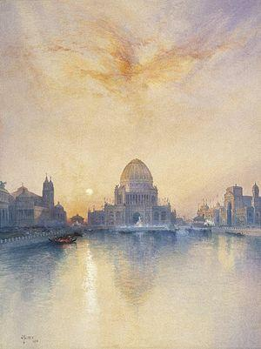
Photo/slide example:

Program notes that correspond to photo/slide example:

Slide 1. The World’s Columbian Exhibition 1893 – also known as the Chicago World’s Fair: The event celebrated the 400 yr anniversary of Christopher Columbus’ arrival to the new world in 1492. Although a dedication ceremony for the fair took place on October 1, 1892, due to financial issues and continuous construction delays, it did not open to the public until May 1, 1893, ending October 30, 1893. Photo: Painting by Thomas Moran, entitled Chicago’s World Fair and is owned by the Brooklyn Museum, Brooklyn NY.

  - Diagrams, maps, graphs – Create, if applicable to program subject.

  - Text – Create bullet points of information, if applicable
Example Text Slide:

The Exhibition Architects
- Daniel Burnham (1846 – 1912) Architect, Urban Designer
- Frederick Law Olmstead (1822 – 1903) Landscape Architect
- John Wellborn Root (1850 – 1891) Architect, Urban Designer

Program notes that correspond to Text Slide example:

Slide 3. The Exhibition Architects – Daniel Burnham, Frederick Law Olmstead and John Wellborn Root were named the leading architects for the creation and execution of the exhibition’s design and construction. With Root’s untimely death, his modern architectural design was abandoned for a classic style. Considered the first example of comprehensive planning in the nation, the fair ground was complete with grand boulevards, classical building facades, and lush gardens. It popularized neoclassical architecture in a monumental way for several decades. Architects in the U.S. were soon asked by clients to incorporate similar elements into their designs.

- Document list of resources on final numbered page of program notes. Include the source of any direct quote, photograph or borrowed idea used in the program. List sources alphabetically by the main author’s name.
- Copy the completed Power Point program and research notes to a dvd-r or flash drive. Print research notes and submit both to the International Second Vice President to approve acceptance for the Questers’ educational resources.
- All Questers who submit Power Point programs are deemed to do so for the benefit of the Questers and all its members. Submission of any program will constitute a non-exclusive assignment to the Questers of any and all rights the creator might have under copyright laws. The Questers may reproduce any program, in whole or in part, for members’ research and education.

