Vol. LXVII Number 2, Winter 2017
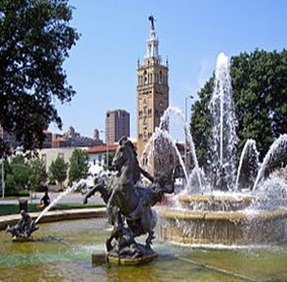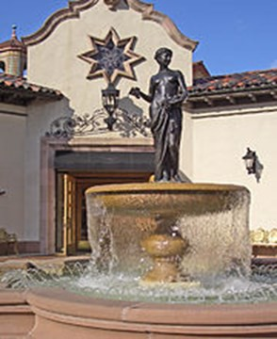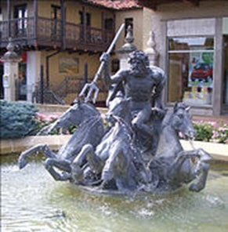

THE MISSOURI QUESTERS ARE EXCITED TO SHOW YOU
THE “SHOW-ME STATE”!

By Jill Waller, 2018 Convention Chairman

The convention starts in Kansas City at the InterContinental on the beautiful Country Club Plaza. The Plaza was built in 1922 and is considered one of the country’s architectural and cultural treasures. J. C. Nichols chose a Spanish theme and included in his plan beautiful courtyards, red tile roofs and ornate towers. There are works of art, sculptures, tile murals, and fountains that adorn the Plaza streets and sidewalks.
We have put together exciting tours that share some of Kansas City, Independence and St. Joseph history. You can see a prairie town, the cargo of a river boat that sank in the Missouri River (all in pristine condition), learn the history of World War I, visit Harry Truman’s Library and the courthouse he pre- sided in, visit beautiful homes of the 19th century and so much more.
The armchair tours will catch your attention. Learn about making jew- elry by hand, find out all the wonderful history that comes from St. Joseph and learn about the fascinating life of Nelly Don.
During the banquet, Kathleen Holeman and the St. Joseph Big Band will have you dancing around the tables! You don’t want to miss the Annual Luncheon on Sunday. “Johnny Holiday” will share his story about Kansas City in the 1920s-1940s. Your jaws will drop!
The Early Bird Program “The Guerrilla War in Civil Missouri” will excite you. It’s amazing all that went on in Missouri. We have four wonderful pro- grams for the Bess Bardens Seminars, given by Missouri Questers. We promise you will enjoy them.
The Post Tour will take you across the state into St. Louis. The first stop will be in the historical town of St. Charles. St. Charles has been welcom- ing visitors since 1769. Then going to downtown St. Louis to explore many his- torical sites. Day 2 you will head to historic Ste. Genevieve, a town on the Mississippi River. (I have been to many of my husband’s family reunions and listened to stories about Aunt Bird who had a hotel in Ste. Genevieve in the 1800s.)
So, come Questers---let the Missouri Questers entertain you with Missouri’s wonderful sites! We will show you a GOOD time!

The 68th International Convention – May 4-6, 2018
Missouri Welcomes You To The Show Me State

PAGE 2 WINTER 2017

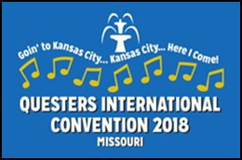
The 68th International Convention
MISSOURI - “Goin’ to Kansas City” - May 4-6, 2018
Founder’s Award Topic - “Missouri - Gateway to the Wild West”

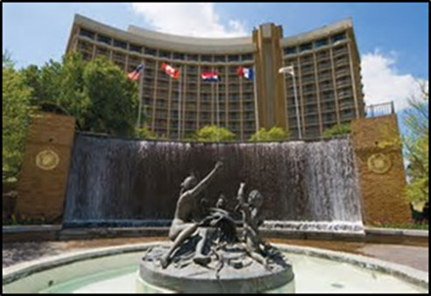
INTERCONTINENTAL HOTEL KANSAS CITY AT THE PLAZA
401 Ward Parkway Kansas City, Missouri

The InterContinental Hotel is located on the beautiful Country Club Plaza within walking distance to over 150 shops. Rooms may be reserved now. You may call toll free at 1-866
-856-9717 and reference The Questers International Convention.
Book online at www.kansascityic.com and enter the group code
of QST. The group rate is $149.00 + tax per night single/double occupancy and $159.00 + tax for triple/quad occupancy. The rate is guaranteed for reservations made before April 9, 2018. Discount rate applies for return- ing post-convention tour on May 9, 2018. There is complimentary overnight self-parking during the conven- tion and post tour discounted self-parking for Monday, May 7, 2018, through Wednesday, May 9, 2018, at
$7.50 per day for up to 25 cars. Complimentary internet access in the guest rooms is included. Check in time is 4:00 PM, check out time is 11:00 AM. The hotel is 30-35 minutes from MCI airport. Estimated taxi fare one- way is $55.00. Airport Shuttle – Call Super Shuttle (800-258-3826) or online www.supershuttle.com.
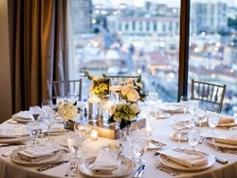NOTE: The InterContinental will not accept multiple reservations as per The Quester’s instruction. Mem- bers will be able to reserve one room only to avoid past over-booking/cancellation problems.
Come N’ Go Buffets will be available to those who register on Thursday and Friday evenings in the Rooftop Ballroom from 5:30-7:00 PM.
Thursday Buffet – KC BBQ - $38.00 (Includes tax & gratuity) Creamy Herbed Cole Slaw, Kansas City Famous Burnt Ends, Hand Pulled Smoked Pork served with an assortment of local BBQ sauces, Bacon Braised Beans, Peach Cobbler, Roasteserie Brewed Coffee, Decaffeinated Coffee, Herbal Tea, Ice Water and Iced Tea.
Friday Buffet – Ultimate Salad - $39.00 (Includes tax & gra- tuity) Kansas City Steak Soup, Grilled Chicken, Baby Shrimp, Mixed Greens, Iceberg, Romaine, Tomatoes, Green Onions, Blue Cheese, Parmesan, Hard- boiled Eggs, Cucumber, Red Onions, Kalamata Olives, Shredded Cheddar Jack, Bacon, Garlic Croutons, Roasted Tomatoes, Variety of Dressings, Lemon Cream Torte, Mini New York Cheesecakes, Roasteserie Brewed Coffee, Decaf- feinated Coffee, Herbal Tea, Ice Water and Iced Tea.
Grab & Go Breakfast will be available for $12.00 (Includes tax & gratuity) for those leaving on early morning tours or to take to the Hospitality Room. It includes orange juice, fresh fruit cup, granola bar and breakfast pastry. Regular breakfast is available in the hotel dining room at regular menu prices. Coffee and tea will be available in the Hospitality Room.

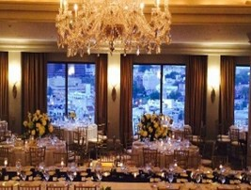EARLY REGISTRATION WEDNESDAY, MAY 2, 2018 4:00-800 PM

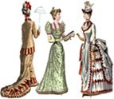
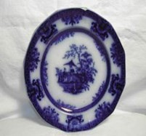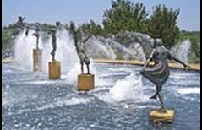
The 68th International Convention In the Beautiful
“City of Fountains”
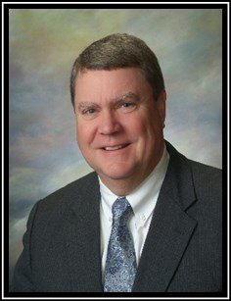
EARLY BIRD PROGRAM
Thursday, May 3, 2018 – 7:30-9:00 PM $10.00
“THE GUERRILLA WAR IN CIVIL MISSOURI”

By Joseph K. Houts, Jr.
Joseph K. Houts, Jr. has published two books, “Quantrill’s Thieves” and “A Darkness Ablaze”. His program will reveal the reasons, horrors and consequences behind the guerrilla war in Missouri during the American Civil War. He will focus in large part on the exploits of Guerrilla Chieftain, Colonel William Clark Quantrill, a Confederate Partisan Ranger, who was the master- mind behind the guerrilla movement. Although a horrible episode in Missouri history, learn how
an initially peaceful populace became the epicenter of terror, retribution and cold-blooded murder. Lastly, he will relate the after effects of the conflict, leading to the rise of the Jesse James and Younger Gang.

BESS BARDENS SEMINARS
Friday, May 4, 2017 – 7:00-8:00 PM and 8:15-9:15 PM
“Button, Button, Who’s Got the Button?”
Presented by Mary Smith-Hyde - Forge #632 & Sheila Hoover-Wild Horse Creek #1317
Well, these two ladies love to share their buttons! Sheila and Mary both believe that “Buttons are the Whole World in Miniature.” You will never know what you’ll find at the bottom of grandmother’s button bag! Buttons are a reflection of our history dating back about 5,000 years. It is a very affordable hobby, the third most col- lectable item only behind stamps and coins. Come JOIN US, LOOK and FEEL, touch our beautiful collections.
“Love That Blue!”
Presented by Rosalie Ingle – Westward HO #173
Flow Blue continues to hold a fascination for those who set eyes on a special piece. A platter caught Rosalie’s attention at a farm auction in 1980, and that purchase developed into a family collecting frenzy. Often one piece leads to the acquisition of an entire collection. Flow Blue Pottery found its way into homes as early as
1820 when the Staffordshire, England potters began their trade. The use of cobalt to produce the familiar “Flow” during the firing process prompted many manufacturers to produce an array of designs on serving pieces and many accessories over the years. Most production ceased by the 1930s. Since then Flow Blue continues to remain popular because of the distinctive flow of cobalt blue colors that adds decorating flare to a home. Four major categories produced were: romantic/ scenic, oriental, floral and brush stroke. Come and enjoy Rosalie and her collection.
“Mid-19thCentury Women’s Fashions”
Presented by Amy Grier – Westward Gateway #1066
Layers upon layers: drawers, chemise, corset, hoopskirt, 2-piece dresses, coats, muffs, bonnets, shawls and gloves. Dressmakers worked from dawn till dusk creating the layers of fashion needed to clothe the women of the 19th century. Eventually with the creation of new vivid dyes, sew- ing machines, and the work of lace makers, the layered look for women’s fashions would soon be lightened. Come see the beautiful wardrobe Amy has sewn and created herself. Share in this 19th Cen- tury Runway Fashion Show with fellow Questers and friends as models.
“1904 Saint Louis World’s Fair Memorabilia”
Presented by Julie Nicolai - Eugene Field #151
Join Julie for a program on the 1904 St. Louis World’s Fair Memorabilia. This Fair was the largest of its era and the only one to gain a net profit. Julie will be showing off examples of Fair Memorabilia from her collection. You will see a rare prize ribbon, metals, photographs, advertisements and souvenir items. You will also learn collecting tips and much fascinating history of the Fair through the lens of its memorabilia. Come check out an exciting period in the history of the St. Louis World’s Fair.
WINTER 2017 PAGE 5

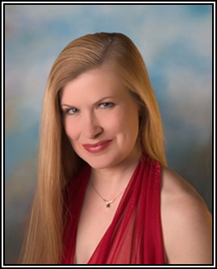
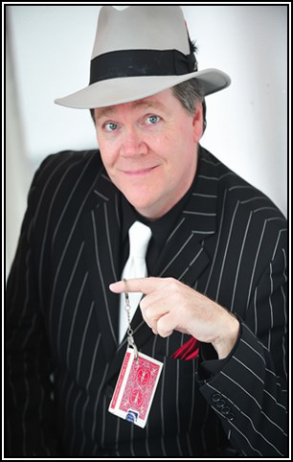
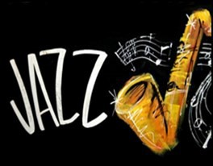
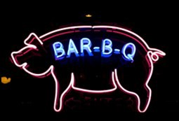
The 68th International Convention In Kansas City, Missouri
Home of the Best Bar-B-Q
PRESIDENT’S RECEPTION & BANQUET
Saturday, May 5, 2018 $65.00
6:00-7:00 PM President’s Receiving Line and Cash Bar 7:00-9:30 PM Dinner and Program

“Jazz with Kathleen Holeman & The St. Joseph Big Band”

Enjoy the smooth jazz performed by Kathleen Holeman and the St. Joseph Big Band. She has graced stages with many world-class musicians both in small combos and large big bands. For over 20
years she’s been performing in clubs, festivals around the Kansas City area and throughout the state and country. Her voice is her main instrument, but she also enjoys playing piano and trombone. The St. Joseph Big Band exists in order to continue the long-standing tradition of big band jazz. In combining the libraries of the Ray Alburn Big Band and the St. Joseph Kicks Band, the new group plans to give their existing fans more of the music
they had loved previously, as well as find new appreciative audiences and dancers.
ANNUAL LUNCHEON
Sunday, May 6, 2018 $60.00
Join in the fun
Cash Bar 11:30 AM – 12:30 PM and wear your
12:30 PM – 4:00 PM favorite flapper or
Lunch and Program gangster costume!
“The Paris of the Plains”
By Kelly Rusk aka Johnny Holiday

“Yo, Questers! Join me for a hysterical tour of Kansas City from back in the day! I’ll tell ya stories about bootleg liquor, I’ll tell ya sto- ries about the gamblin’ joints, I’ll tell ya about widespread prostitution, I’ll tell ya about the shootouts and even a few explosions. Ya know… THE GOOD OLE DAYS! From the 1920s to the mid 1940s Kansas City was known as a Wide-Open Town and I got all the lowdown on what was goin’ on. So, let’s have some fun and learn about the REAL history of Kansas City!”

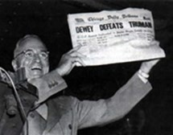
The 68th International Convention
President Harry S. Truman opened a men’s clothing store in Kansas City, Missouri
Armchair Tours with Lunch

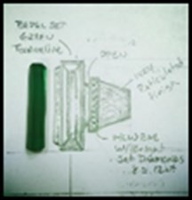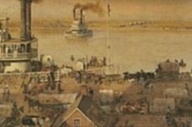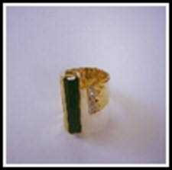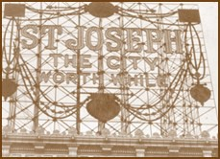Armchair A $39.00 Thursday, May 3, 2018 Lunch Noon – 1:00 PM Program 1:00 PM – 2:00 PM

“Add More Color to Your Life!
Presented by Joseph Montanari
For over 40 years, Joseph Montanari and his talented staff have been making heirloom quality jewelry by hand, from raw gems to finished product, earning nine national or international design awards along the way. Share Joe’s enthusiasm for diamonds, gems, and the fine art of jewelry design.

Armchair B $39.00 Friday, May 4, 2018
Program 10:30 AM – 11:30 AM
Lunch 11:30 AM – 12:30 PM

“St. Joseph, Missouri-The City Worth While That is Worth Your While”
Presented by Sarah Elder
“Where the Pony Express began and Jesse James end- ed,” has long been the phrase that describes St. Joseph. Well, as important as these two events are, this Queen of the River Towns has a lot more to its history and a lot more to look forward to in its future. Come on this journey as we explore 170+ years of St. Joseph history to see what makes St. Joseph so “Worth While.”

Armchair C $39.00 Friday, May 4, 2018
Program 10:30 AM – 11:30 AM
Lunch 11:30 AM – 12:30 PM

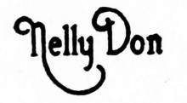
Presented by Diane Montague

Ellen Quinlan aka Nell Donnelly Reed, the fashion designer behind the Nelly Don fashion trend of the 1920s, revolutionized the affordable fashion industry and became a millionaire in the process. Nell’s dresses were seen every- where from skyscraper galas to modest homes of everyday hardworking women. Her company was based out of Kan- sas City and the story of her personal and professional life is one for the ages. The program will pay homage to the ideals and principles of Nell Donnelly and the company she so dearly loved with vintage designs, prints, patterns, fabrics and attire for any situation.

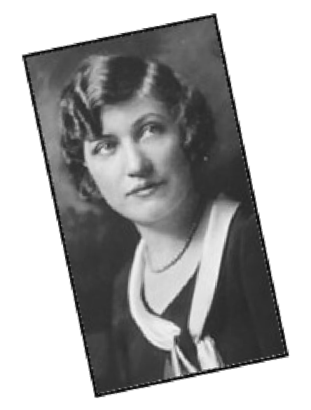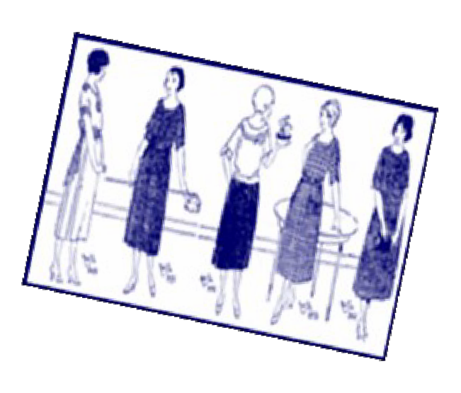

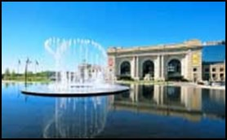
The 68th International Convention
Kansas City has more miles of boulevards than Paris and more fountains than any city except Rome.

All tours leave from the Ballroom Level, West Door.
Meet 15 minutes prior to tour departure and wear comfortable shoes.
Full Day Thursday Tours, May 3, 2018 Lunch Included

Tour 1 Toys n’ Tunes: National Toy & Miniatures Museum & Marr Sound Archives 9:30 AM – 4:30 PM $50.00 Lunch on UMKC Campus
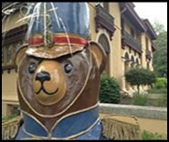Be amazed at art, architecture, jewelry and the things we deal with in our everyday lives, only in tiny, tiny form. Explore generations of childhood through dolls, dollhouses, trains, soldiers, teddy bears and more. Marr Sound Archives (one of only two “sound” museums in the US) brings you to the inner sanctum to experience the “sound” of no longer published early 20th century re- cordings. (Trivia: Walt Disney designed UMKC’s Mascot and the elementary school he attended is still on campus, now in use by the university.)

Tour 2 Fly Me to the Moon: Kansas City Airline History Tour
9:30 AM – 4:30 PM $60.00 Lunch at Trezo Mare
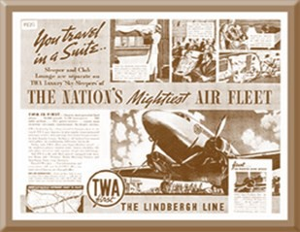
In 1927 Charles Lindberg dedicated MKC-Kansas City Airport. View airline history film, artifact museum and handsome historic aircraft from the piston-driven engine era (plus a relic L- 10ll jet) with staff that includes retired TWA pilots and flight mechanics here at the downtown airport. At the TWA Museum archives are exclusively devoted to the airline’s history as created by Howard Hughes and based in Kansas City; uniforms, staff histories, many historic photographs and yes, staff that includes retired flight attendants. Airplanes and TWA, forever together in Kan- sas City.

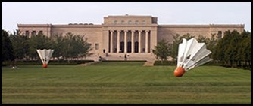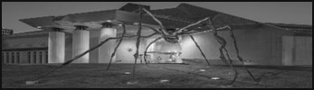Tour 3 Museum Day: Nelson-Atkins Museum, Kemper Gallery of Modern Art & KC Art Institute
9:30 AM – 4:30 PM $52.00 Lunch in Rozzelle Court
These three great treasures of KC all have national and international significance. The Nelson experience will focus on an exclusive collection, the Kemper is intimate with its modern art. The Kansas City Art Institute, for more than 130 years, is right in the neighborhood with a snapshot tour of its most historic building, where Walt Disney learned, Thomas Hart Benton lectured, and Robert Rauschenberg studied fashion design.

Tour 4 Entrepreneurs of Clay County:
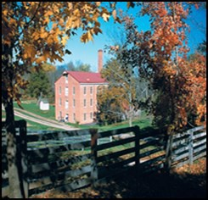Watkins Woolen Mill SHS in Lawson & Hall of Waters, Excelsior Springs Museum 9:15 AM – 4:30 PM $50.00 Lunch at Willow Spring Mercantile
Clay County, Missouri became the new home for western bound immigrants from Ken- tucky, Tennessee, Virginia and Ohio in the mid-19th century. Their risk-taking spirits included Waltus Watkins the entrepreneur who, with his mill and mercantile, revolutionized the manufacture of wool fabric. Still intact are the historic looms you won’t find anywhere else. The Reverend James and sons, Jesse and Frank, were from Kearney. Reverend Flack and his wife brought news to the world about the healing waters of Excelsior Springs.

Tour 5 Queen City, Independence
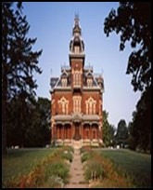9:15 AM—4:30 PM $59.00 Lunch at the Bingham-Waggoner Estate
Tour includes the Vaile Mansion, Truman Library, Courthouse and the Bingham-Waggoner Estate. The Queen City of the Trails welcomes you. The Oregon, California, Santa Fe and Mormon Trails all pushed west into the Kansas Territory. Harry had his first job off the farm, rose to become Eastern Court Judge, and then our President. George Caleb Bingham and Colonel Harvey Vaile built mansions to their wealth and passion. The Vaile Mansion was the priciest house and the most comfortable home in the en- tire west. It’s a three story, 31 room, Gothic-like structure. The Bingham-Waggoner Estate offers its own special look into an earlier era.

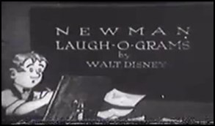
The 68th International Convention Walt Disney got his start in Kansas City Laugh-O-Gram Films

Full Day Thursday Tours, May 3, 2018 Lunch Included

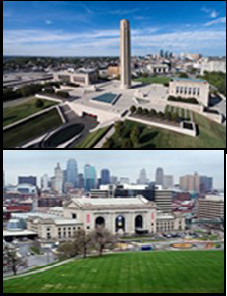
Tour 6 Signboard Hill Transformed: WWI Museum, Hallmark Cards Visitor Center & Walking History Tour of Union Station
9:30 AM - 4:30 PM $63.00 Lunch at Crown Center
Soon after World War I ended, Kansas City leaders formed the Liberty Memorial As- sociation to create a lasting monument to the men and women who had served in the war. In 1921, more than 100,000 people gathered to see the dedication of the site of the Liberty Memorial. For more than 100 years, Hallmark Cards has called Kansas City home. In 1969, the Hall Family created the Crown Center Complex, Hallmark Cards headquarters, lux- ury office space, hotel, shops and restaurants. The 100 year-old Union St ation is a hub of cul- ture, education and entertainment. The beautifully restored Union Station is a site to behold.

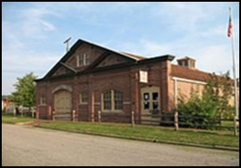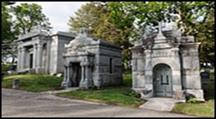Tour 7 Off the Beaten Track, St. Joseph, MO – Missouri’s First and Last Frontier
8:15 AM – 4:30 PM $63.00 Lunch at the Benton Club
The old State Lunatic Asylum #2, now the Glore Psychiatric Museum, is only one of six museums of its kind in the country. Visitors are fascinated by this self- contained city that once housed over 3,000 patients. You will hear the stories of wealthy Victorians, Pony Express Riders, an English knight, war heroes, and view fantas- tic mausoleums in this historic 1851 unusual Mt. Mora Cemetery. Enjoy lunch and hear the history of the oldest men’s social club west of the Mississippi at the Benton Club. Mount up and head for the Pony Express National Museum where mail delivery began April 3, 1860. Both locations have been the recipients of Questers’ grants.

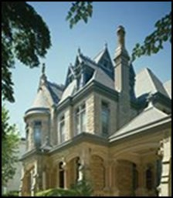Tour 8 Preservation & Architecture, St. Joseph, MO
8:15 AM – 4:30 PM $69.00 Lunch at the Wyeth-Tootle Mansion Tour the lavish Shakespeare Chateau Mansion atop a high bluff on “Millionaires’ Row,” boasting 47 original artisan-crafted stained-glass masterpieces. Experience a special treat, a driv- ing tour featuring incredible architecture. Tour the Wyeth-Tootle Mansion. This Gothic mansion from the 1880s offers many rooms that have been restored to their original elegance for a look at life in the Victorian age. Visit the Vineyard Mansion & Carriage House. The style is Richardsonian Romanesque with multiple bay windows, turrets and gables. There’s an interest-
ing link between Abraham Lincoln and this home.

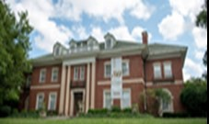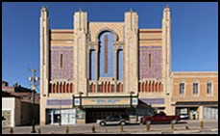Tour 9 Art Along the River, St. Joseph, MO
8:15 AM – 4:30 PM $69.00
Lunch at the Albrecht-Kemper Museum
Tobiason’s has over 50 years of experience in designing, fabricating, installing and restoring church windows throughout the country. See how they create these timeless win- dows. You also have the experience of creating your own stained glass “angel”. Enjoy a gourmet lunch and view one of the finest collections of American art in the Midwest at the Albrecht-Kemper Museum of Art (also the home of the founder of the Big Chief Tablet). Step into an elegant, restored 1926 movie palace, the Missouri Theater, where citizens con- tinue to enjoy movies and live productions. Both buildings have been the recipients of Questers’ grants.

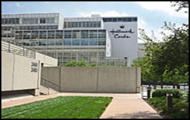
The 68th International Convention
In 1910, Joyce C. Hall begins selling postcards out of a shoebox, leading to the creation of the world’s largest
greeting card company, Hallmark Cards

All tours leave from the Ballroom Level, West Door.
Meet 15 minutes prior to tour departure and wear comfortable shoes.
Full Day Friday Tours, May 4, 2018 Lunch Included

Tour 10 | Repeat of #1 – Toys n’ Tunes: National Toy & Miniatures Museum and Marr
 | Sound Archives
 | 9:30 AM – 4:30 PM $50.00 Lunch Included
Tour 11 | Repeat of #2 – Fly Me to the Moon: Kansas City Airline History Tour
 | 9:30 AM – 4:30 PM $60.00 Lunch Included
Tour 12 | Repeat of #3 – Museum Day: Nelson-Atkins Museum, Kemper Gallery of Modern
 | Art & KC Art Institute
 | 9:30 AM – 4:30 PM $52.00 Lunch Included
Tour 13 | Repeat of #4 – Entrepreneurs of Clay County: Watkins Woolen Mill & Hall of Waters
 | 9:15 AM – 4:30 PM $50.00 Lunch Included
Tour 14 | Repeat of #5 – Queen City, Independence: Truman Sites, Bingham-Waggoner Estate &
 | Vaile Mansion
 | 9:15 AM – 4:30 PM $59.00 Lunch Included
Tour 15 | Repeat of #6 – Signboard Hill Transformed: WWI Museum, Hallmark Cards
 | Visitor Center & Union Station
 | 9:30 AM – 4:30 PM $63.00 Lunch Included
Tour 16 | Repeat of #7 – Off the Beaten Track, St. Joseph, MO
 | 8:15AM – 4:30 PM $63.00 Lunch Included
Tour 17 | Repeat of #8 – Preservation & Architecture, St. Joseph, MO
 | 8:15 AM – 4:30 PM $69.00 Lunch Included
Tour 18 | Repeat of #9 – Art Along the River, St. Joseph, MO
 | 8:15 AM – 4:30 PM $69.00 Lunch Included
Hospitality Room
Before you stroll around the Plaza, stop by The Questers’ Hospitality Room conven- iently located in the InterContinental Hotel; grab a cup of coffee or tea and a directory of shops with a passport for shopping discounts. Did you know that the Plaza has nineteen foun- tains, four wishing wells and one hundred fifty shops? Be sure to enter the attendance drawings for small gift baskets donated by Missouri Questers. Come back and enjoy some iced tea and visit with Questers from all over. There will be tables displaying Missouri Questers’ col-
lections. Do you need an idea for a chapter project? There will be a video on many of Missouri chapters’ projects that will be playing in a continuous loop. The Hospitality Room welcomes you!
PAGE 10 | WINTER 2017

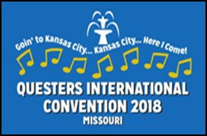
The 68th International Convention
Kansas City’s swing sound jazz dates back to the 1930s when legendary Count Basie played
in the area’s clubs.
Half Day Saturday Tours, May 5, 2018 Lunch Included

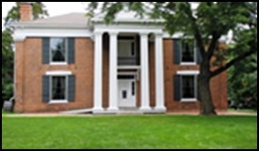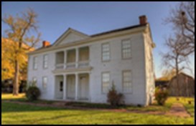Tour 19 Trail Outfitters on the Border: John Wornall House & Alexander Majors House
12:30 PM – 4:30 PM $55.00 BBQ Lunch Included

The John Wornall House was built in 1858. The house served as a Civil War battlefield hospital for both Union and Confederate soldiers during the Battle of West- port. The Alexander Majors House is most famous for Alexander Majors’ ventures with the Pony Express and creating a commercial portal for the westward expansion of the United States. The Museum also offers a working blacksmith shop. You will enjoy a Kansas City Barbecue luncheon buffet in the barn.

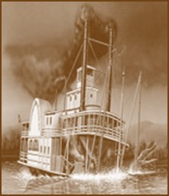Tour 20

City of Kansas 1850s: Steamboat Arabia
12:30PM – 4:30 PM $57.00 Lunch in The River Market

1856 – what a big year in Western Missouri on the Big River (MO). When the mighty steamboat Arabia sank near Kansas City on September 5, she carried 200 tons of mystery cargo. Lost for 132 years, her recovery in 1988 was like finding the King Tut’s Tomb of the Missouri River. See remarkably preserved tools, clothes, guns, dishware and more. The discovery was truly a modern-day treasure hunting story at its best. Experience the largest collection of pre-civil war artifacts in the world.

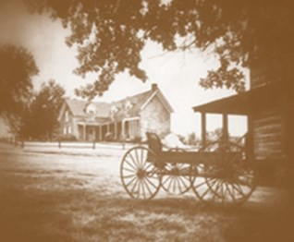Tour 21 Shoal Creek Living History Museum: Victorian High Tea
(30 Persons Only) High Tea in the Thornton Mansion 12:30 PM – 4:30 PM $50.00
Walking tour of the village buildings with costumed guides. The museum has 21 structures including 17 authentic log cabins and homes, relocated from sur- rounding counties, dating from 1807-1885 to create a village setting. Thornton Mansion is your host for High Tea and a self-guided tour of the buildings and grounds. Shoal Creek is a recipient of many Questers’ grants.

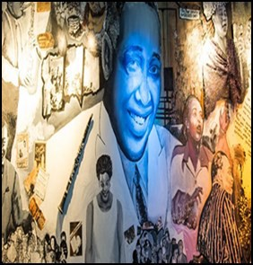Tour 22 KC Jazz District: American Jazz Museum & Negro Leagues Museum 12:30 PM – 4:30 PM $55.00 Lunch at KC Juke Joint

Located in the Historic 18th and Vine Jazz District, the American Jazz Museum showcases the sights and sounds of jazz through interactive exhibitions and films, visual arts treasures (including one of Louis Armstrong’s horns and a sequined gown worn by Ella Fitzgerald), the Blue Room Jazz Club and the Gem Performing Arts Center. In the same facility is the Negro Leagues Baseball Museum. NLBM was conceived as a museum to tell the complete story of Negro Leagues Baseball in the 20th century, from the average play- er to the super star. The Juke Joint is famous for “Soul Food” in a neighborhood setting.

2018 International Convention Schedule
4:00 pm – 8:00 pm | Wednesday, May 2, 2018 | Early Registration Pavilion Lobby
Meet 15 Minutes before tour leaves | Thursday, May 3, 2018 | Dinner Buffet or Dinner on Own
7:00 am – 5:00 pm Registration Pavilion Lobby
7:00 am – 9:30 am Grab & Go Breakfast Pavilion Lobby
7:00 am – 11:00 am & 3:00 pm – 5:00 pm Hospitality, Sales & Display Pavilion I
9:30 am – 4:30 pm Tour 1 - Toys n’ Tunes Ballroom Level, West Door
9:30 am – 4:30 pm Tour 2 – Fly Me to The Moon Ballroom Level, West Door
9:30 am – 4:30 pm Tour 3 – Museum Day: Ballroom Level, West Door
9:15 am – 4:30 pm Tour 4 – Entrepreneurs of Clay County Ballroom Level, West Door
9:15 am – 4:30 pm Tour 5 – Queen City, Independence Ballroom Level, West Door
9:30 am – 4:30 pm Tour 6 – Signboard Hill Transformed Ballroom Level, West Door
8:15 am – 4:30 pm Tour 7 – Off the Beaten Track, St. Joseph, MO Ballroom Level, West Door 8:15 am – 4:30 pm Tour 8 – Preservation & Architecture, St. Joseph, MO Ballroom Level, West Door 8:15 am – 4:30 pm Tour 9 – Art Along the River, St. Joseph, MO Ballroom Level, West Door Noon – 2:00 pm Armchair Tour A – “Add More Color to Your Life!” Rooftop Ballroom
5:30 pm – 7:00 pm Hotel Buffet Dinner Rooftop Ballroom
7:30 pm – 9:00 pm Early Bird Program – “The Guerrilla War in Civil Missouri” Ballroom Level, Salon II

Meet 15 Minutes before tour leaves Friday, May 4, 2018 Dinner Buffet or Dinner on your own
7:00 am – 5:00 pm Registration Pavilion Lobby
7:00 am – 9:30 am Grab & Go Breakfast Pavilion Lobby
7:00 am – 11:00 am & 3:00 pm – 5:00 pm Hospitality, Sales & Display Pavilion I
9:30 am – 4:30 pm Tour 10 – Repeat of #1 - Toys n’ Tunes Ballroom Level, West Door
9:30 am – 4:30 pm Tour 11 – Repeat of #2 - Fly Me to The Moon Ballroom Level, West Door
9:30 am – 4:30 pm Tour 12 – Repeat of #3 - Museum Day: Ballroom Level, West Door 9:15 am – 4:30 pm Tour 13 – Repeat of #4 - Entrepreneurs of Clay County Ballroom Level, West Door 9:15 am – 4:30 pm Tour 14 – Repeat of #5 - Queen City, Independence Ballroom Level, West Door 9:30 am – 4:30 pm Tour 15 – Repeat of #6 - Signboard Hill Transformed Ballroom Level, West Door 8:15 am – 4:30 pm Tour 16 – Repeat of #7 - Off the Beaten Track, St. Joseph, MO Ballroom Level, West Door 8:15 am – 4:30 pm Tour 17 – Repeat of #8 - Preservation & Architecture, St. Joseph, MO Ballroom Level, West Door 8:15 am – 4:30 pm Tour 18 – Repeat of #9 - Art Along the River, St. Joseph, MO Ballroom Level, West Door 10:30 am – 12:30 pm Armchair Tour B – “St. Joseph, Missouri-The City Worth While… ” Rooftop Plaza Room 10:30 am – 12:30 pm Armchair Tour C – “Nelly Don” Rooftop Ballroom
1:00 pm – 4:00 pm State/Provincial Presidents Meeting Pavilion III
1:00 pm – 4:00 pm Future Convention Chairmen Meeting Pavilion II
5:30 pm – 7:00 pm Hotel Buffet Dinner Rooftop Ballroom 7:00 pm & 8:15 pm Bess Bardens – “Button, Button, Who’s Got the Button?” Pavilion II
7:00 pm & 8:15 pm Bess Bardens – “Love That Blue!” Pavilion III 7:00 pm & 8:15 pm Bess Bardens – “Mid-19th Century Women’s Fashions” Pavilion VI 7:00 pm & 8:15 pm Bess Bardens – “1904 Saint Louis World’s Fair Memorabilia” Pavilion VII

Meet 15 Minutes before tour leaves Saturday, May 5, 2018
7:00 am – 6:00 pm Registration Pavilion Lobby
7:00 am – 8:00 am Grab & Go Breakfast Pavilion Lobby
7:00 am – 8:00 am & 3:00 pm – 5:00 pm Hospitality, Sales & Display Pavilion I
8:30 am – 9:30 am International Workshop – Chapter Presidents Pavilion III
8:30 am – 9:30 am International Workshop – Organizers/Membership Pavilion II
8:30 am – 9:30 am International Workshop – Treasurers Pavilion VI
8:30 am – 9:30 am International Workshop – Program/Yearbook/Facebook Ballroom Level, Salon 1B 8:30 am – 9:30 am International Workshop – Parliamentarians Pavilion VII
8:30 am – 9:30 am International Workshop – Newsletter/Website Editors Left Side Ballroom Lobby 8:30 am – 9:30 am International Workshop – P & R Right Side Ballroom Lobby
10:00 am – 11:00 am Open Forum Ballroom Level, Salon 1A, 1B
12:30 pm – 4:30 pm Tour 19 – Trail Outfitters on the Border Ballroom Level, West Door 12:30 pm – 4:30 pm Tour 20 – City of Kansas 1850s: Steamboat Arabia Ballroom Level, West Door 12:30 pm – 4:30 pm Tour 21 – Shoal Creek Living History Museum: Victorian High Tea Ballroom Level, West Door 12:30 pm – 4:30 pm Tour 22 – KC Jazz District & Negro Leagues Museum Ballroom Level, West Door 5:15 pm – 6:30 pm Official Photographs To Be Announced
6:00 pm – 7:00 pm President’s Receiving Line & CASH BAR Ballroom Level, Ballroom Lobby
7:00 pm – 9:30 pm Banquet Ballroom Level, Ballrooms 1A,1B, II,III
Sunday, May 6, 2018

7:00 am – 8:30 am  7:00 am – 8:30 am  8:00 am – 8:30 am  9:00 am – 11:00 am | Grab & Go Breakfast Hospitality, Sales & Display Registration  Annual Council Meeting | Pavilion Lobby Pavilion I Pavilion Lobby  Ballroom Level, Salon 1A, 1B
11:30 am – 12:30 pm | Cash Bar | Ballroom Lobby
12:30 pm – 4:00 pm | Annual Luncheon | Ballroom Level, Ballrooms 1A,1B,II,III
4:30 pm – 5:30 pm | Post Convention Tour Meeting | Hospitality Room

Monday, May 7, 2017 – Post Tour leaves at 8:00 am from Ballroom Level, West Door. Drop off extra bags.

Member: ( ) Yes ( ) No NON-MEMBERS (If you are a guest, please list the member’s name)

Official Delegates: Check your designation below and include completed DELEGATE AUTHORIZATION FORM
( ) Chapter Pres. ( )St/Prov Pres. ( )Unch St/Prov Org. ( )Int’l Appt. Chair ( )Past Int’l Pres. ( )Alternate
PLEASE NOTE: Each attendee member and guest must fill out a separate registration form and pay the registration fee to attend any part of the convention. Guests must be accompanied by a Quester member. For guaranteed registration send this form and fees to the Registrar by April 1, 2018. No refunds on cancellations postmarked after April 1, 2018. See Convention Policy below. REGISTRATION FEE is NOT refundable. PLEASE PRINT CLEARLY.
OFFICIAL REGISTRATION FORM 68TH INTERNATIONAL CONVENTION May 4 – 6, 2018 - INTERCONTINENTAL HOTEL, KANSAS CITY, MISSOURI

Last Name |  | First Name | Chapter Name & Number
Street Address |  | City & State or Province | Zip Code/Postal Code
Telephone | Cell | Email Address | Emergency Name/Telephone

Quester Registration Postmarked by April 1, 2018 | $40.00 | $ | BESS BARDENS SEMINARS  Friday, May 4, 2018  Make two choices  “Button, Button, Who’s Got the Button?”  ( ) 7 PM ( ) 8:15 PM  “Love That Blue!”  ( ) 7 PM ( ) 8:15 PM  “Mid 19th Century Women’s Fashions”  ( ) 7 PM ( ) 8:15 PM  “1904 Saint Louis World’s Fair Memorabilia”  ( ) 7 PM ( ) 8:15 PM  MAKE CHECKS OR MONEY ORDERS (US FUNDS ONLY)  PAYABLE TO:  2018 Questers International Convention  Mail: Total Funds Registration Form  Delegates Form (if applicable) Mailing Labels – See Note*  TO: Merry Burtner Registrar  P..O. Box 6365  St. Joseph, MO 64506  816-233-9341, Cell 816-248-2850  gotoKCMO2018@gmail.com  Do you have any DIETARY RESTRICTIONS??? Please note:
Host State Registration Postmarked by April 1, 2018 Guest Registration Postmarked by April 1, 2018 Registration Postmarked after April 1, 2018 Double the $ | $20.00  $50.00 | $  $  $
In the bracket to the left of the tour, please mark your preference: 1st, 2nd and 3rd choices. Include payment for 1st choice only.
Thursday, May 3, 2018 Full Day Tours With Lunch  ( ) Tour 1 – Toys n’ Tunes Tour 1  ( ) Tour 2 – Fly Me to the Moon Tour 2  ( ) Tour 3 – Museum Day Tour 3  ( ) Tour 4 – Entrepreneurs of Clay County Tour 4  ( ) Tour 5 – Queen City Independence, MO Tour 5  ( ) Tour 6 – Signboard Hill Transformed Tour 6 ( ) Tour 7 – Off the Beaten Track, St. Joseph, MO Tour 7 ( ) Tour 8 – Preservation & Architecture, St. Joseph, MO Tour 8 ( ) Tour 9 – Art Along the River, St. Joseph, MO Tour 9 ( ) Armchair A “Add More Color to Your Life” w/Lunch  ( ) Hotel Buffet Dinner  ( ) Early Bird – “The Guerrilla War in Civil Missouri” | $50.00  $60.00  $52.00  $50.00  $59.00  $63.00  $63.00  $69.00  $69.00  $39.00  $38.00  $10.00 | $  $  $  $  $  $  $  $  $  $  $  $
Friday, May 4, 2018 Full Day Tours With Lunch  ( ) Tour 10 – Repeat of #1 – Toys n’ Tunes Tour 10 ( ) Tour 11 – Repeat of #2 – Fly Me to the Moon Tour 11 ( ) Tour 12 – Repeat of #3 – Museum Day Tour 12 ( ) Tour 13 – Repeat of #4 – Entrepreneurs of Clay City Tour 13 ( ) Tour 14 – Repeat of #5 – Queen City, Independence Tour 14 ( ) Tour 15 – Repeat of #6 – Signboard Hill Transformed Tour 15 ( ) Tour 16 – Repeat of #7 – Off the Beaten Track Tour 16 ( ) Tour 17 – Repeat of #8 – Preservation & Architecture Tour 17 ( ) Tour 18 – Repeat of #9 – Art Along the River Tour 18  ( ) Armchair B “St. Joseph, MO – The City Worth While” w/ Lunch ( ) Armchair C “Nelly Don” With Lunch  ( ) Hotel Buffet Dinner | $50.00  $60.00  $52.00  $50.00  $59.00  $63.00  $63.00  $69.00  $69.00  $39.00  $39.00  $39.00 | $  $  $  $  $  $  $  $  $  $  $  $
Saturday, May 5, 2018 Half-Day Tours With Lunch  ( ) Tour 19 – Trail Outfitters on the Border Tour 19 ( ) Tour 20 – City of Kansas 1850s: Steamboat Arabia Tour 20 ( ) Tour 21 – Shoal Creek Living History Museum Tour 21 ( ) Tour 22 – KC Jazz District & Negro League Museum Tour 22 ( ) PRESIDENT’S RECEPTION & BANQUET  Sunday, May 6, 2018  ( ) ANNUAL LUNCHEON & MEETING  Total Remitted on U.S. Check or Money Order | $55.00  $57.00  $50.00  $55.00  $65.00  $60.00  Total | $  $  $  $  $  $  $
 |  |  |  | If you have mailing labels, it would help the Registrar if you includ- ed 4 in the envelope with this registration form for use in labeling envelopes for mailing and convention.
CONVENTION POLICY 4E
Fees for Convention Events will be refunded up to the deadlines as stated on the Registration Form (April 1, 2018). If funds are available, after Convention expenses are paid, refunds may be made at the discretion of the Convention Chairman and the Registrar. Registration fees are non-refundable.
Registration confirmation card: Please check one
Send confirmation info to my email address
Send confirmation info to my home address
 |  |  |  | Sign your registration form at packet pick-up at the conference in 2018.
WINTER 2017 |  |  |  | PAGE 13

DELEGATE AUTHORIZATION FORM

OFFICIAL DELEGATE AUTHORIZATION FORM

2018 International Council Meeting
INTERNATIONAL BYLAWS – ARTICLE XV INTERNATIONAL COUNCIL
Section 1. The members of the International Council who are eligible to vote shall be the elected members of the International Execu- tive Board, current International Appointed Chairmen, Past International Presidents, State/Provincial Presidents (or designated alter- nate), State/Provincial Organizers (or designated alternate) in Unchartered States/Provinces, and the President (or alternate) of each chapter.

International Council delegates sit in the designated area for Council Members at International Council Meeting.
Each Voting Delegate attending the International Convention must submit a signed Delegate Authorization Form. If an alternate is designated: the alternate must be an ACTIVE, not an associate, member in good standing in the same State/Provincial/ Chapter organization as the official Delegate; State/Provincial President’s alternate must have State/Provincial Board approval.

ELECTED MEMBER OF THE INTERNATIONAL EXECUTIVE BOARD (IEB): (No alternate)
NAME (Please Print)
POSITION HELD STATE/PROVINCE
IEB member’s Signature

INTERNATIONAL APPOINTED CHAIRMEN: Int’l Parliamentarian, Int’l P&R Chairman, QQ Editor, Int’l Publicity Chairman, Int’l Website Editor, Membership Chairman (No alternates)
NAME (Please Print)
POSITION HELD STATE/PROVINCE
International Chairman’s Signature

PAST INTERNATIONAL PRESIDENT: (No alternate)
NAME (Please Print)
Past International President’s Signature STATE/PROVINCE

STATE/PROVINCIAL PRESIDENT:
NAME (Please Print) STATE/PROVINCE
(DESIGNATED ALTERNATE, an active, current or incoming, member of the same State/Provincial Board)

(Please Print)
State/Provincial President or Vice President’s Signature

UNCHARTERED STATE/PROVINCIAL ORGANIZER:
NAME (Please Print) STATE/PROVINCE (DESIGNATED ALTERNATE, an elected, active member in the same State/Province) Organizer’s Signature

CHAPTER PRESIDENT:
NAME (Please Print) __ ___ CHAPTER NAME & NUMBER STATE/PROVINCE
(DESIGNATED ALTERNATE, an active member of the same chapter)
Chapter President or Vice President’s Signature

IF APPLICABLE, INCLUDE THE DELEGATE AUTHORIZATION FORM WITH YOUR REGISTRATION.
Send to: 2018 International Convention Registrar Merry Burtner, P.O. Box 6365, St. Joseph, MO 64506

INTERNATIONAL CONVENTION POST TOUR—MAY 7, 8, 9, 2018
“Springtime in St. Louis” May 7, 8 & 9, 2018
Registration Deadline is March 28, 2018
Spring in St. Louis and eastern Missouri and the river valley beckons the dogwood blossoms in the country, the tulip trees and rose gardens in the city. Experience this May tour in communities along the Mississippi River rich in French, Spanish and German history,
Tour Includes: Round trip chartered luxury motor coach transportation from InterContinental Hotel, professional tour operator escorts your entire journey, driver gratuity, St. Charles city tour with costumed guide, lunch at St. Charles Boone’s Colonial, Cathedral Basilica guided tour, 2 nights deluxe lodging at historic Drury Hotel at the Arch in the heart of downtown St. Louis, luggage handling, kickback buffet and 3 cocktails per person, Day 1, 2, dinner and show at historic Bissell Mansion, complimentary hot breakfast buffet, Day 2,3, lunch at the Blue Owl in Kimmswick, day excursion to Ste. Genevieve city, property tours, dinner at Audubon’s, Dred Scott story and Old Courthouse excursion, guided tram tour – Missouri Botanical Garden, lunch and tour at Lemp Mansion, option to purchase travel insurance.
Day 1: Monday, May 7, 2018
8:00 AM: Depart InterContinental Hotel Kansas City 10:00 AM: Restroom Stop
12:30 PM: Lunch and Step on Tour – Historic St. Charles 3:00 PM: Guided tour at the Cathedral Basilica, St. Louis 4:30 PM: Check in Drury Hotel
5:30 PM: Depart for Bissell Mansion
plated dinner & show
9:00 PM: Arrive back at the Drury Hotel
Day 2: Tuesday, May 8, 2018
Breakfast Buffet at Hotel
9:15 AM: Tram tour at Missouri Botanical Garden 10:45 AM: Depart for Ste. Genevieve
11:30 AM: Lunch Included at the Blue Owl in Kimmswick 1:00 PM: Arrive Ste. Genevieve.-Tour with
costumed guide
1:30-4:30 PM: Tour of 18th century sites & organ recital at the Ste. Genevieve Catholic Church (1794)
5:00-8:00 PM: Wine reception with guest speaker;
Followed by plated dinner at Audobon’s Restaurant
Return to St. Louis and the Drury Hotel
Day 3: Wednesday, May 9, 2018
Breakfast at hotel and check out
9:30 AM: Depart hotel for Courthouse
10:00AM- Arrive at the Old Courthouse & Museum, site 11:30 AM: of the Dred Scott Trial (reenactment included).
One of the most important cases ever tried in the U.S. In 1857, The Supreme Court decided the case, hastening the start of The Civil War.
11:45 AM: Lunch included & tour, Historic Lemp Mansion 1:30 PM: Depart for Kansas City & InterContinental
Hotel
20 minute rest stop in route
5:30 PM: Drop guests at the InterContinental Hotel
Reservation Form Post Convention Tour “Springtime in St. Louis”
May 7, 8 & 9, 2018
Registration Deadline is March 28, 2018
Price per Person: Double $575.00 Single Supplement: $231.00
Motor Coach Tour is based on a minimum of 30 guests. If fewer than 30, the trip will be subject to cancellation. Reservations are on a first come, first served basis. $100 deposit is due with reser- vation. Balance is due by March 28, 2018. A 3% fee applies to payments made with a credit/debit card. Cancellation: Reserva- tion deadline is March 28, 2018. No refunds will be issued after this date.
You must be a registered participant of The Questers Convention and attend at least one paid official function (President’s Recep- tion/Banquet, Annual Luncheon) in order to participate.
Passenger Information:
First Name: Last name: Gender: M F
Address: City: State: Zip: Phone No: Email Address: Date of Birth: Day Month Year Dietary Restrictions: Emergency Contact: Emergency Contact Phone: Sharing a room, please state roommate:
Please send this form with your $100 deposit (3% fee ap- plies to credit/debit card payment). Make checks payable to: Montague Tour Design
Diane Montague CTA, IATA 523 Elms Boulevard Excelsior Springs, MO 64024 816-616-2336
diane@montaguetourdesign.com
Allianz Essential Travel Insurance Plan
Covers Trip Cancellation/Trip Interruption* up the 100% of Trip cost and/or Travel Interruption:
Receive up to $150.00 PP to cover additional accommodation/travel expenses and lost prepaid expenses due to a departure delay of six or more hours. 24-hour Hotline Help. $69 Per Person: Please include your payment with your trip deposit. Contact Diane Montague for brochure. Additional terms and conditions apply.
Reasons covered for trip cancellation and interruption include covered illness, traffic accident, Jury Duty, travel delay resulting in loss of 50% of trip length and more.

