WHAT IS A QUESTER?
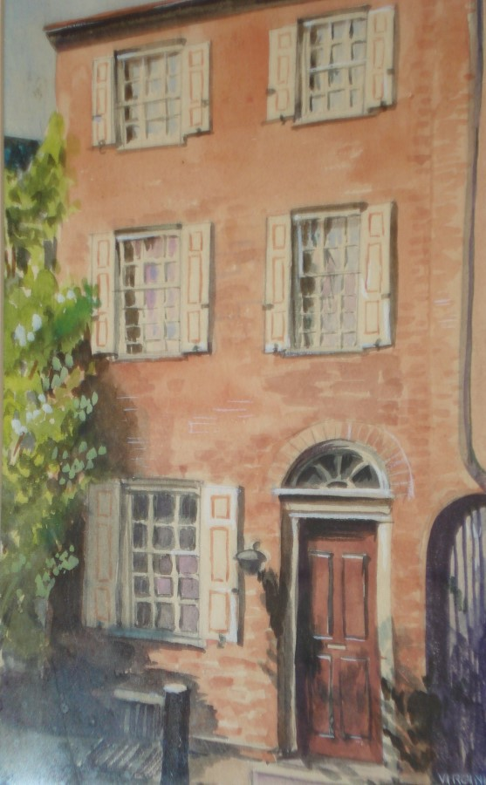
The year 1944 was full of misery for many people. Everyone was so weary of the War, and many had lost loved ones. Morale was slipping so anything that could give it a boost was needed. This is what Jessie Elizabeth Bardens (Bess Bardens), who was a Red Cross production chairman living in Fort Washington, Pennsylvania, had in mind when she invited a group of her co-workers to her home. They were to "bring an antique and a sandwich.” She had purchased a little blue syrup pitcher from a shop near work in October 1943. On her way to and from work, what would be more natural than to stop at an antique shop if you were passing by?
After showing this pitcher to her co-workers and discussing it, others stopped by her desk and more questions were asked with still more discussion following. This started a whole stream of small antiques being brought to work by her co-workers just so Mrs. Bardens could give her opinion on them. This convinced her something was needed. So, on April 6, 1944, she invited fourteen ladies

to come to her home for more discussion and study. By the end of that year, there were 35 people meeting to learn more about antiques. At this time, most homes could not accommodate this many people, so Mrs. Bardens encouraged all those wanting to become Questers to form their own study groups. Before long, there were five more groups. In March 1950, Mrs. Bardens organized THE QUESTERS into a national organization and in 1953, incorporated it under the laws of the Commonwealth of Pennsylvania as a non-profit corporation. Mrs. Bardens was the first National Questers President, serving from 1950-1956.

Word spread and inquiries about forming chapters as well as how to affiliate existing antiques clubs with this national organization came from all over the country. Mrs. Bardens personally went where she could to organize these groups. The rest she did by mail. She always made it a point to answer all questions. In 1954, she and her husband drove as far west as Iowa, organizing chapters as they went.
Mrs. Bardens had a large and choice collection of tea caddies that she was frequently asked to talk about. She gave a sterling silver tea caddy to her friend Mildred Hanna of Michigan, THE QUESTERS National President from 1964-1966. Some years later Mildred donated it to THE QUESTERS Headquarters in Philadelphia.

Revised October 2023
Before Mrs. Bardens passed away in 1963, she attended the first National Questers Convention and saw THE QUESTERS organization grow to 149 chapters located in 22 states. The only states that have never had a Questers chapter are Vermont and Hawaii. Now, there are approximately 507 chapters in 34 states and 2 Canadian provinces. Although there have been Canadian chapters since 1967, THE QUESTERS did not officially adopt the designation of International organization until 1990!
THE QUESTERS is a non- profit organization that promotes preservation and restoration of artifacts, memorials, historical buildings and landmarks. In addition, a two-year Scholarship is given to a student at Columbia University’s Graduate School of Architecture, Planning and Preservation (GSAPP) and a three-year Fellowship is awarded to a student enrolled at the Winterthur/University of Delaware Program in Art Conservation (WUDPAC).
International Bylaws and International, State/Provincial, and Chapter Policies govern the Questers. There are both International officers and State/Provincial officers. Also, each chapter has its own officers. Any Quester who meets prescribed criteria can become an officer. The slate of nominees for the election of State, Provincial and International officers is selected because of their personal qualifications and their experience serving at the chapter, state and provincial levels. All members should take turns becoming a chapter officer to make the experience better for all members. Everyone brings something different to a job well done.

An individual becomes a “Quester” when he or she joins an existing chapter or joins a group of at least six individuals (male or female of all ages) to form a new chapter. Chapters are chartered as a subsidiary of THE QUESTERS, a 501(c)(3) non-profit organization. The number of members in a chapter varies and is determined by the membership, often influenced by where the chapter holds its meetings. Meetings may be held in members’ homes or in public spaces such as libraries, churches or meeting rooms at retirement villages, etc.

When Mrs. Bardens was asked, "What is a Quester?" she gave this answer: "A Quester is a socially well-adjusted intelligent person who has curiosity, enthusiasm, imagination and a good memory. For the greatest powers of the mind are memory and imagination, for without memory we have no past, without imagination, no future." She also said, "A Quester spends time constructively, does research about the history of antiques and collects knowledge. Sooner or later the 'Bug Bites' and they have acquired a hobby and are a collector."

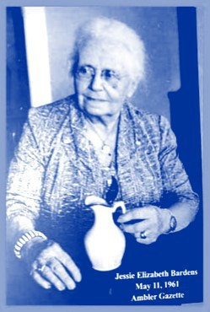

Revised October 2023

